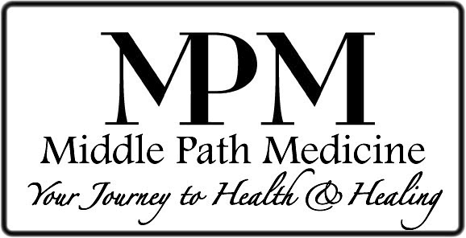

Gary E. Foresman, MD

Welcome to Middle Path Medicine! We would like to introduce you to Gary E. Foresman, MD, Founder and Director of Middle Path Medicine. Our staff is dedicated to assisting you on your journey to health and healing. In this welcome packet, you will find brochures and handouts regarding the Wellness Evaluation, BioImpedance Analysis, the Foundations of Health, the Basic Nutritional Protocol, and information about the services available to you from the team here at Middle Path Medicine.

Here is just a sampling of the information and health assistance Middle Path Medicine offers:

- Gary E. Foresman, MD – Board Certified Internal Medicine Specialist, Integrative Medicine, and Integrative Oncology Fellow
- Bobby Maybee, DC – Chiropractic care, including pain reduction using K-Laser Therapy. Dr. Maybee offers FREE initial evaluations by appointment.
- Kathi Fennelly, NP – Women’s Health specialist, treating PMS, menopause, hormone management; also available for annual exams and pap smears.
- Intravenous Nutrition Therapy – Administered under the direction of Dr. Foresman by our Registered Nursing staff. IV Therapy can be used to support your immune system, as an adjunct to chemotherapy, for surgery and travel preparation, and to address many other specific needs.
- Supplement Shop – Offering the finest herbal and vitamin nutritional support available anywhere. Each supplement is hand selected by Dr. Foresman. Our Supplement Shop offers a 15% discount for our 55 and over shoppers, and everyone can take advantage of 10% off most items every Saturday! Many of our favorite supplements are available for Buy One, Get One FREE!
- Www.MiddlePathMedicine.com – Your primary source of information regarding any health concern. While visiting, sign up for our E-Mail Newsletters for the latest articles from Dr. Foresman and our entire staff, as well as our frequent Community Health Update details and sale announcements.

What to Expect

When you become a patient, you will go through our Wellness Evaluation – this is a time to establish your chart, obtain information regarding you, and run some simple and effective tests that help us measure how well you are. The Wellness Evaluation takes between 30 and 45 minutes and includes a tour of our office so you can actually see what we have to offer.

Your initial appointment with Dr. Foresman will be about an hour long. This will give you time to discuss your health concerns in detail. In order to make the most of your visit, please follow these suggestions:

- Write down questions you have and bring a pen and paper for notes.
- Bring any supplements, vitamins, and medicines you are taking so he can review them.
- He will provide a copy of your specific recommendations for your reference.
- The Middle Path Medicine Supplement Shop is here to serve you should the doctor prescribe any supplements. We are happy to help you in our shop immediately following your visits. Getting the exact prescription given to you by Dr. Foresman is the only way to ensure our ability to help you on your journey to health and healing. Most importantly, the staff at MPM can translate his utterly illegible handwriting!

Follow up visits are usually 30 minutes long, but you can schedule longer appointments when necessary. You are welcome to call MPM if you have any questions!

Our staff is here to make your visit a comfortable and positive experience. Every effort is made to confirm and keep your appointment time. Please take the time to review our cancellation policy. We request that you check in at our front desk 15 minutes prior to your scheduled appointment. This allows time for the Medical Assistant to check you in, take your vitals, and update any information in your chart.

Once again, welcome to Middle Path Medicine; we look forward to supporting you on your journey to health and healing!

Gary E. Foresman, MD
Founder & President

Bobby Maybee, DC
Chiropractic Care

Kathi Fennelly, NP
Women’s Health Specialist

Veronica Stevenson
Medical Assistant

Miranda Foresman
Office Manager

Lynda Savidge
Shop & Marketing Director
Joy Reyes
Medical Assistant

Gary Michael Foresman
Shop & Web Design

Richard Ragadio
Medical Reception

